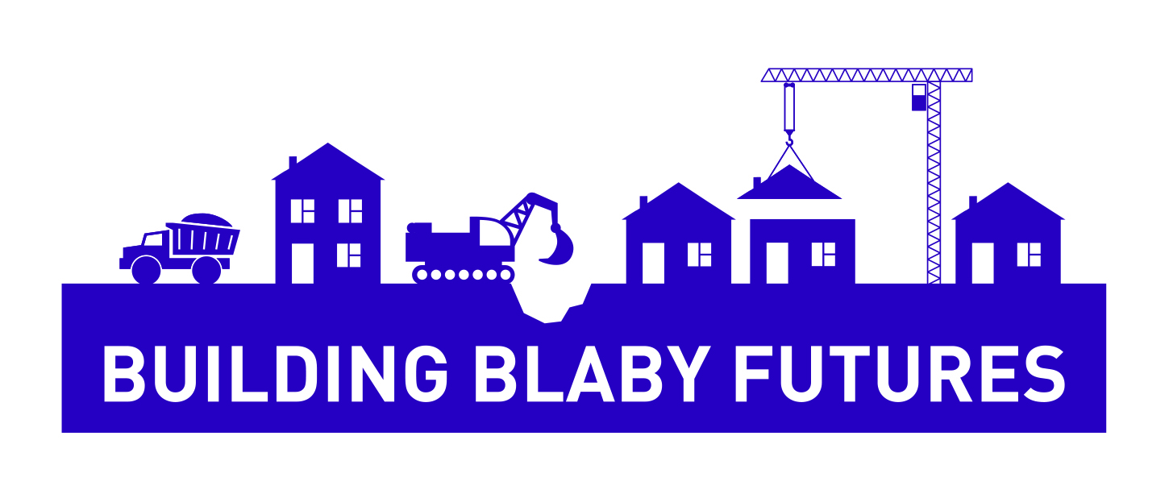

**Mindfulness**

FREE SESSION

Mindfulness is a mind-body based approach that helps people to manage their thoughts and feelings and mental health. Mindfulness exercises are ways of paying attention to the present moment, using techniques like meditation, breathing and yoga.

If you would to find out more about mindfulness come along to a free session being held at the Council offices in Narborough.

The session is being delivered by My Solution Wellbeing and is part of Blaby District Councils Housing, Work and Life Skills Programme

To secure a place please ring Jill Carr on 0116 272 7725 or email housingskills@blaby.gov.uk

**Thursday 10th October 2019 1.00pm to 3pm**

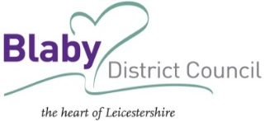**Blaby District Council Offices, Narborough**