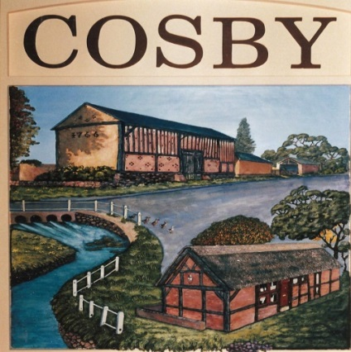
COSBY PARISH COUNCIL
Clerk: Mr Les Phillimore
c/o 76 Springwell Lane
Whetstone
Leicester
LE8 6LT
Telephone: 07802 303936
clerk@cosbyparishcouncil.gov.uk

GRANTS TO VOLUNTARY ORGANISATIONS – GUIDELINES

Cosby Parish Council will consider applications from groups and organisations which are able to demonstrate a tangible benefit to some or all of the parishioners of Cosby. These may include sports groups, toddler groups, non-profit making organisations, charities and other village groups.
The Parish Councils grant award policy will support locally based or locally active groups whose ambition is to support local residents and help Cosby to become a better place to live, work and visit and where equality, diversity and inclusivity are actively promoted.
Cosby Parish Council administers 2 small grant awarding bodies with a total grant fund of £2,000, Cosby Parish Council (£1,000) and Cosby Recreation Ground Charity (£1,000). Successful applications will be awarded from either fund at the Parish Councils discretion with individual grant applications not expected to exceed £250.00 per application. Exceptions to the maximum grant award may be made for village wide events and activities at the Parish Councils discretion.
Cosby Parish Council applies no prescribed criteria as to which community activities that a grant award may be made towards other than there should be a visible and / or tangible benefit to the residents of Cosby and the grant award falls within the legislative powers that the Parish Council holds or aligns with the constitution of the Recreation Ground Charity.
Applications must be received by the Parish Manager together with any supporting documentation required. The Parish Manager may request additional information to allow recommendations to be made to the Parish Council – please note the final paragraph on page 2 when submitting applications as applications without the required documentation will not be considered.
Timings: An annual grant award announcement is made in the local newsletters around April of each year although grant applications, subject to available funds, can be considered at any time and the Parish Manager will indicate to the Parish Council, which legislative power a grant award applies to or whether S137 would apply.
If an application is successful, payment will be made to the Organisation (not to an Individual) on receipt of any requested supporting documentation, i.e., copy invoices. All applicants will be notified of the Parish Council decision by the Parish Manager.
Only one grant per organisation will be made within each financial year (April to March). Separate applications must be made in future years if further grants are to be sought and no more than three consecutive grant awards are likely to be successful within a five-year period. The Parish Council may consider requests outside of these terms with a sufficiently robust business case or demonstrable community benefit. NB: Grant applications that cannot demonstrate a clear and tangible benefit to the parish or residents of Cosby may be automatically declined.

COSBY PARISH COUNCIL - SMALL GRANT POLICY

GRANT APPLICATION FORM

Please complete in Block capitals
Name of
Organisation
Registered Charity no (if applicable)
Purpose of Organisation
Total No of  Members |  |  | No of members residing in the parish
Contact name
Contact Address |  |  |  |  | Postcode
Telephone: |  |  | Fax No
Email address: |  |  | Web Site

Amount of Grant applied for | £ (NET OF VAT)
Purpose of Grant
Details of other bodies approached for funding

This application form and a copy of the most recent audited accounts (for all accounts held by the organisation) along with the latest bank statement should be forwarded to the Parish Manager along with this application form. Applications are only considered for a single grant award in each financial year and only in exceptional circumstances to non-village organisations.
The Parish Council has limited grant funding available and cannot make substantial grants (Over £1,000) available. Other bodies should therefore, be approached for financial assistance for larger grants i.e., over £1,000.

This Section for Parish Council use:
Date Received: | Date considered:
Council Recommendation: Y / N | Minute Number:
Amount of Grant £
Date paid. | Cheque/FPS No.
Legislative power?

CPC Village Small Grant Policy – October 2023
Approved 16th November 2023

Prepared by Les Phillimore
Parish Manager
For implementation Financial Year 2024/25

